
a
Company
Logotype

Cone Beam Computed Tomography- Report



Porur Dental X-rays & CBCT

Patient Name : Mr. Nithilan | Date of Report : 11.05.2024
Age/ Gender : 17 years/ Male | Region of Interest : CBCT Full Skull
Referring doctor: 32 Dental Care | Indication : Orthodontic assessment
Clinical Notes: Nil
PATIENT INFORMATION

CBCT- Full Skull provided
CBCT – IMAGE DETAILS

RADIOGRAPHIC INTERPRETATION

- No of teeth present in the maxillary and mandibular arch: 32;
- Retained deciduous teeth: 71, 81; Missing tooth: 31, 41.
- Erupting teeth: 18, 28; mesioangular: 38
- Bilateral Class I molar relationship evident.
- Cross bite evident in relation to the left upper and lower premolar region.
- The maxillary and mandibular alveolar ridge are present with normal trabecular pattern.
- Deviated nasal septum towards the right side is evident; the right nasal passage appears narrow when compared to the left side.
- Midline shift of the lower arch towards the left; the teeth 11, 12, 13 appears distally tipped and the teeth 21, 22 appears mesially tipped.

RADIOGRAPHIC IMPRESSION

- Retained deciduous teeth: 71, 81
- Partial anodontia: 31, 41
- Malocclusion
- Deviated nasal septum

Kindly correlate with clinical findings


IMAGES FOR REFERENCE

RECONSTRUCTED PANORAMIC VIEW
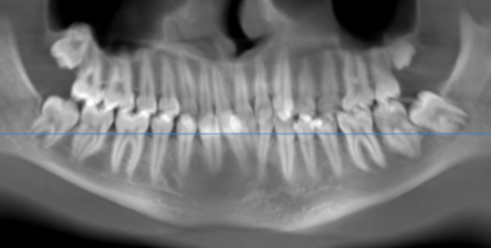

3-DIMENSIONAL VIEW

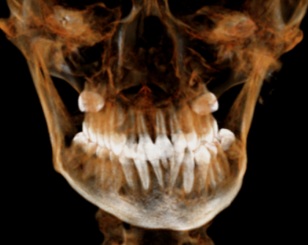

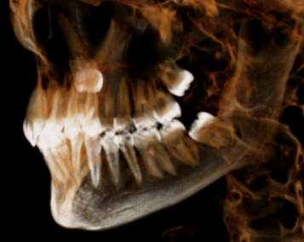
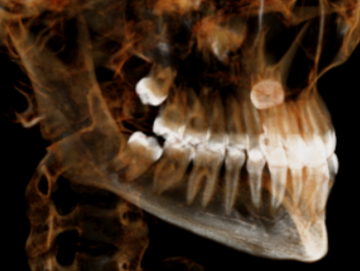

CORONAL VIEW
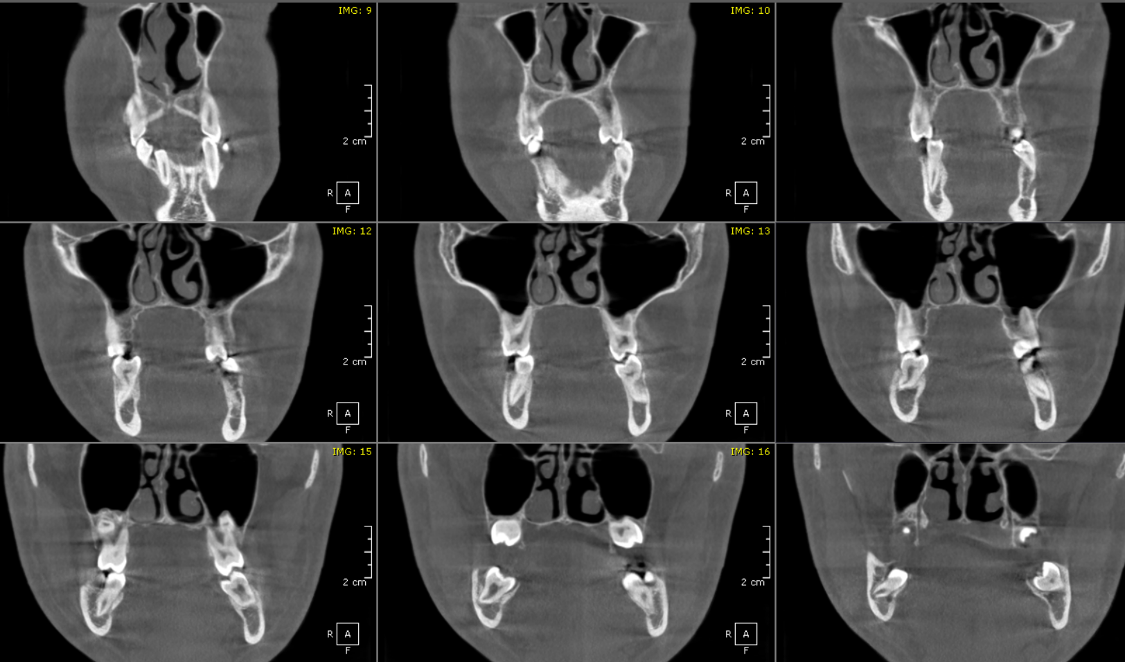

SAGITTAL VIEW

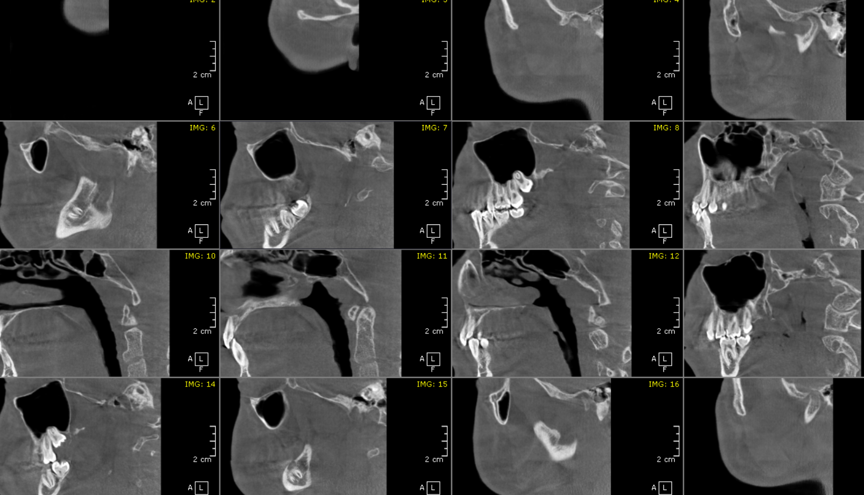

**** End of report ****

